ECEN 429: Introduction to Digital Systems Design Laboratory

North Carolina Agricultural and Technical State University

Department of Electrical and Computer Engineering

Freddie Boadu (Reporter)

Mike Umelo (Partner)

April 8, 2020

Pre Lab #9

**Introduction**

This prelab deals with doing vending machines. This week in the lab we are going to be using the vhdl to be able to do a vending machine controller. The concepts of a counter and register will be used for this week’s lab to complete the task. This will focus on using all those components together to make the controller and the overall datapath.

**Background, Design Solution and Results**

This prelab provides use insight into how a vending machine would work on the boards and what it entails in terms of the vhdl system.

Problem 1:

Each state represents the amount of money at that state. The states need to be added up to know a total amount based on the nickels or dimes added to the states. So S4 would mean nickel and dime which is 15 cents being added total to the system at that point in the state. Step 3 is more of the same. Step 3 takes it a step up and you can see that at 15 cents there is an output. A vending machine when a certain amount of a “money” has been reached it should allow the user to get an output.

Problem 2:

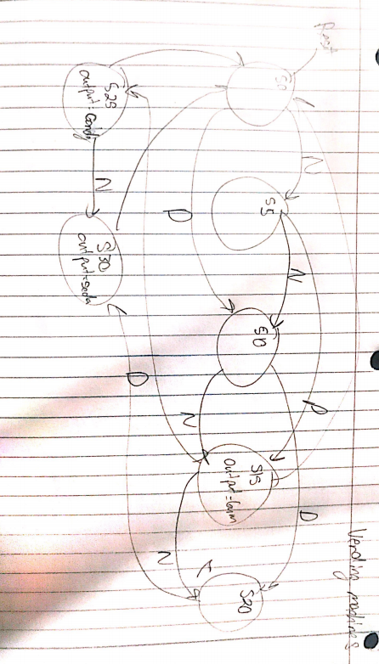

**Conclusion**

After doing the prelab, I understand the relationship between the vending machine and its components.